TOP 5 MODELS FOR ASD

Combined dataset used - Dataset-1 link - <https://www.kaggle.com/datasets/fabdelja/autism-screening-for-toddlers>

Dataset - 2 - <https://www.kaggle.com/datasets/uppulurimadhuri/dataset>

Dataset - 3 - https://www.kaggle.com/datasets/andrewmvd/autism-screening-on-adults

Code @ - <https://github.com/UjjwalPardeshi/asd_prediction>

1. CatBoost Training Accuracy: 0.9987

CatBoost Testing Accuracy: 0.9773

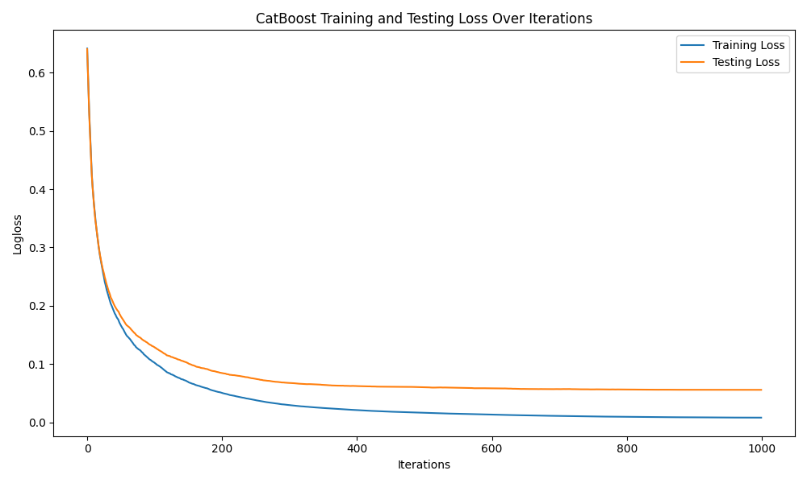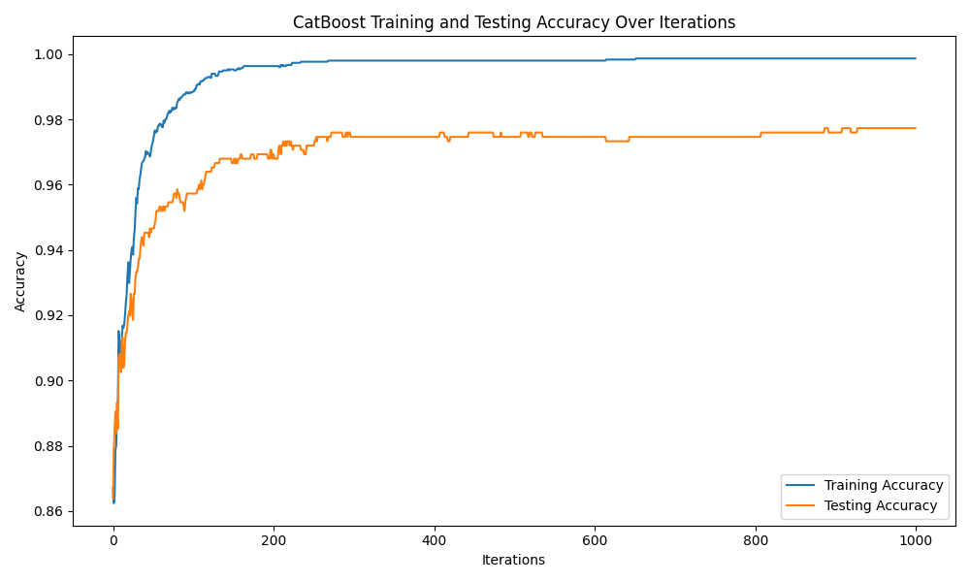

1. XGBoost Training Accuracy: 0.9987

XGBoost Testing Accuracy: 0.9746

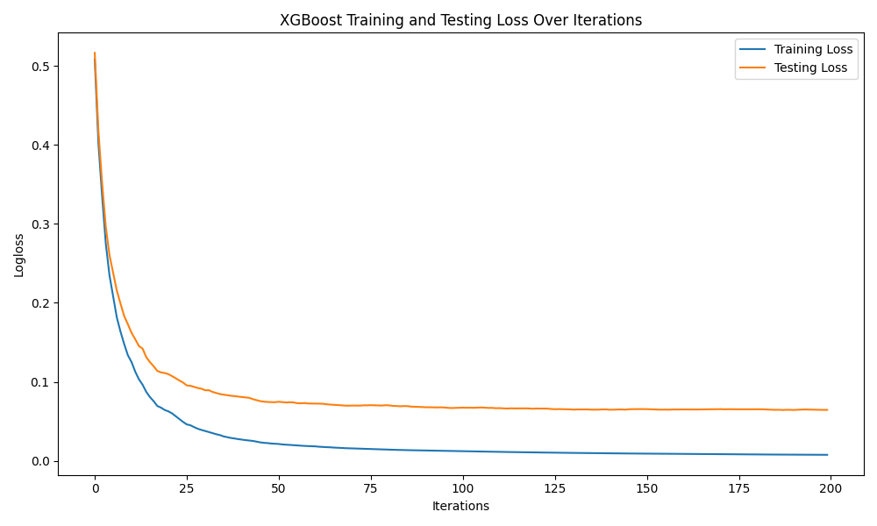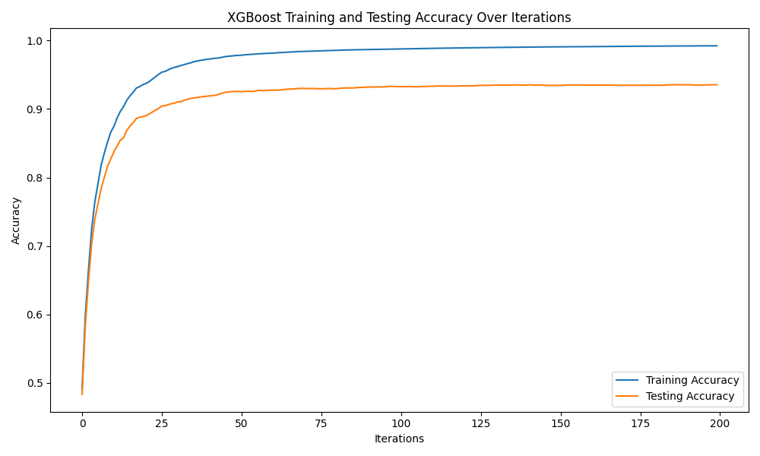

1. DNN - Train Accuracy: 0.9920, Test Accuracy: 0.9720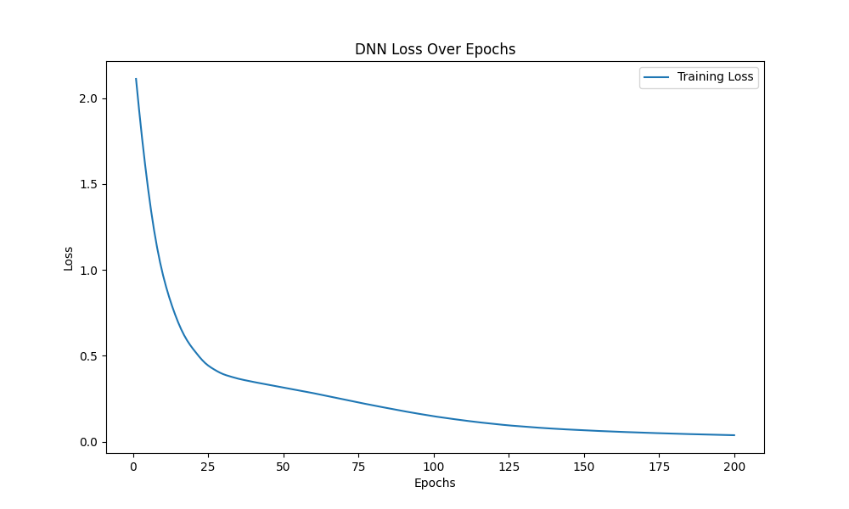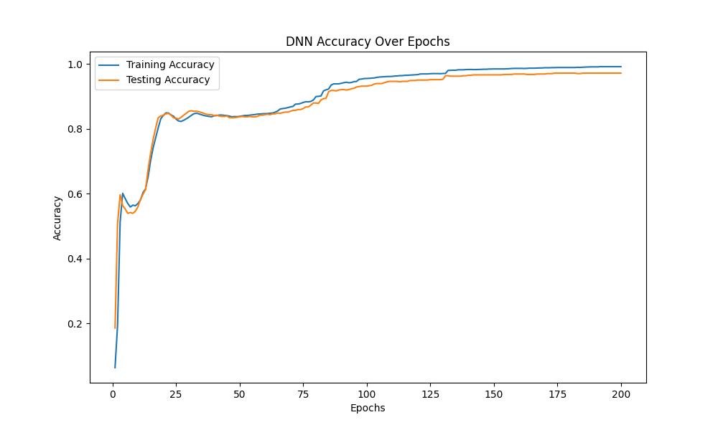
2. Stacked Ensemble Training Accuracy: 0.9987

Stacked Ensemble Testing Accuracy: 0.9693

Base Models: Random Forest, XGBoost, and LightGBM

Logistic Regression is used as the meta-model for stacking.

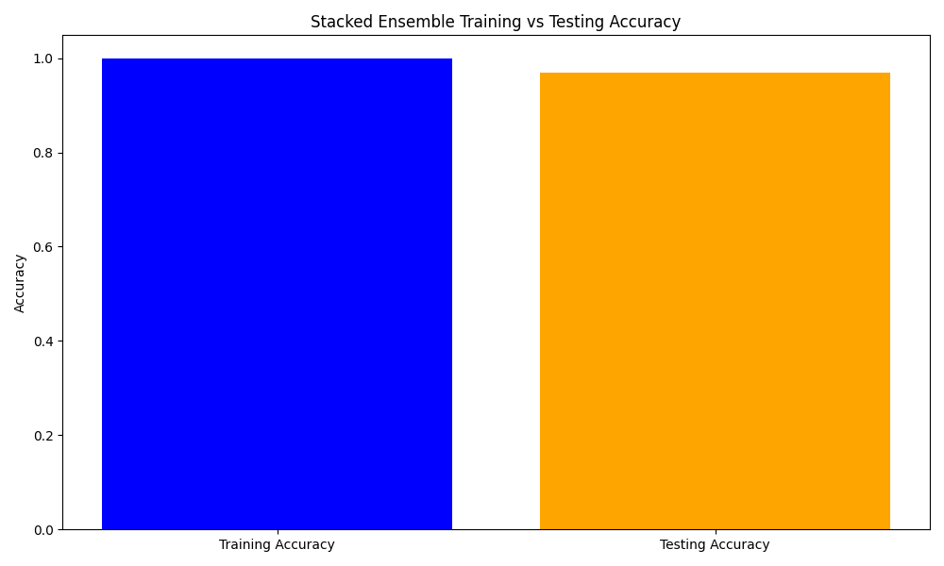

1. Accuracy for Random Forest (Training): 0.9987

Accuracy for Random Forest (Testing): 0.9653

